**OUTPUT SCREENS**

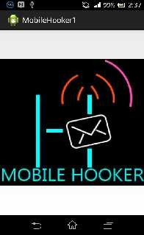

Tap up to continue Sliding Menu

**Demo Pages:**

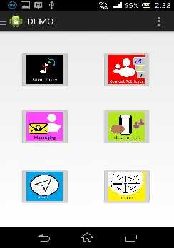

Home Page

56

SRK INSTITUTE OF TECHNOLOGY

MOBILE HOOKER

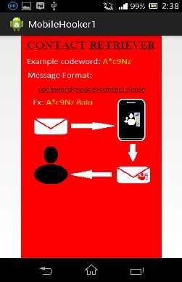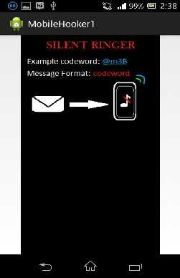

Demo for Silent Ringer Demo for Contact Retriever

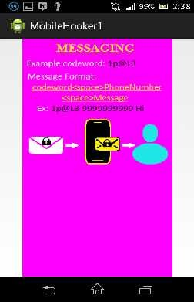

Demo for Messaging

57

SRK INSTITUTE OF TECHNOLOGY

MOBILE HOOKER

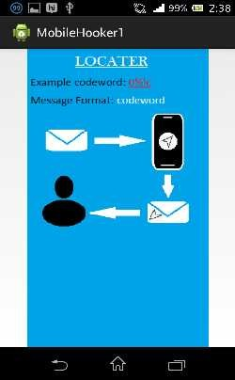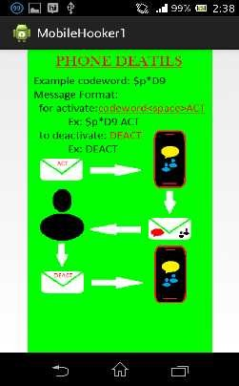

Demo for Phone Details Demo for Locater

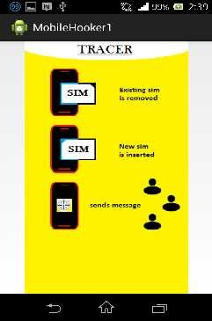

Demo for Tracer

58

SRK INSTITUTE OF TECHNOLOGY

MOBILE HOOKER

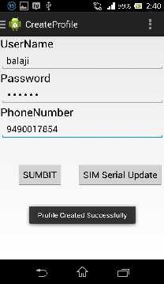

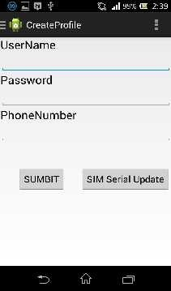

Create Profile Page Profile Creation

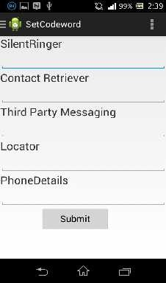

Set Codeword Page

59

SRK INSTITUTE OF TECHNOLOGY

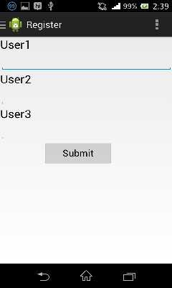MOBILE HOOKER

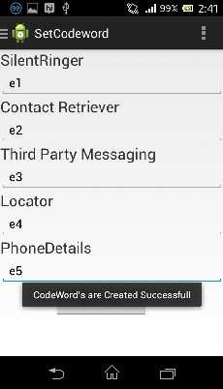

Codeword Creation Register Page for Tracer

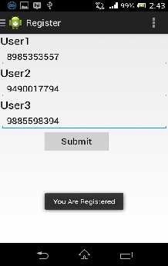

Tracer Registration

60

SRK INSTITUTE OF TECHNOLOGY

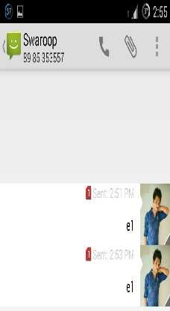MOBILE HOOKER

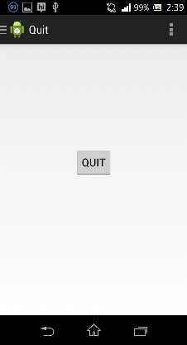

Quit Page Codeword sent for silent ringer

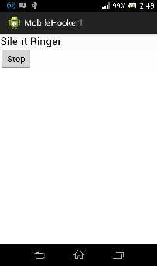

Page to stop the ringing notification

61

SRK INSTITUTE OF TECHNOLOGY

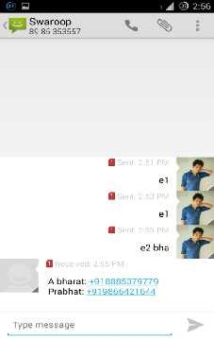MOBILE HOOKER

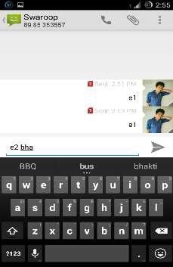

Codeword sent to Contact Retriever Contacts retrieved from user’s phone

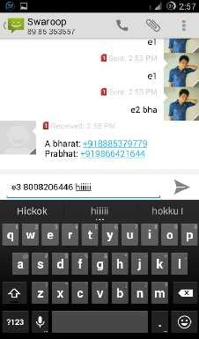

Codeword sent to Messaging

62

SRK INSTITUTE OF TECHNOLOGY

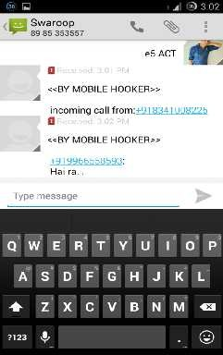MOBILE HOOKER

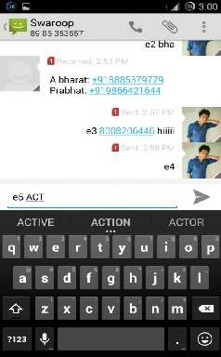

Codeword and ACT sent to Phone Details Call log retrieved from user’s phone

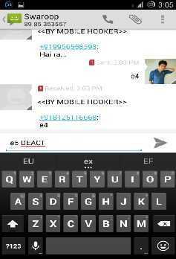

Codeword and DEACT sent to user’s phone

63

SRK INSTITUTE OF TECHNOLOGY

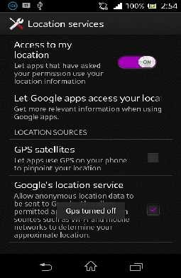MOBILE HOOKER

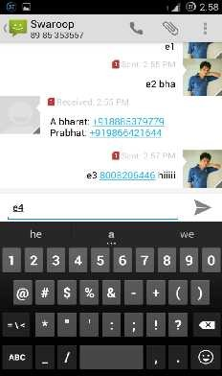

Codeword sent to Locater GPS automatically on